Final Project Report Template
1. Introduction

1.1 Project Overview
This project analyzes smartphone usage behavior and its relationship with digital well-being, screen time, sleep, social media usage, gaming, stress, and addiction levels. The analysis is implemented in Microsoft Power BI using the Smartphone_Usage dataset. Four analytical sheets were developed to move from individual visualizations to interactive dashboards and deeper report-level insights.

1.2 Objectives
- Measure overall smartphone usage and digital behavior using key performance indicators.
- Compare screen time, sleep, social media, gaming and work/study usage across user groups.
- Examine differences by gender, age group, stress level and addiction level.
- Create interactive Power BI visualizations and dashboards for quick interpretation.
- Identify patterns and potential relationships that can support digital well-being analysis.

2. Project Initialization and Planning Phase

2.1 Define Problem Statement
High levels of smartphone engagement can be associated with changes in sleep, social media behavior, stress, productivity and general digital well-being. A structured analytical report is therefore required to summarize usage patterns and make the underlying data easier to interpret.

2.2 Project Proposal (Proposed Solution)
The proposed solution is a Power BI-based analytical model containing KPI cards, comparison charts, categorical distributions, relationship plots, filters and key-influencer analysis. The four sheets documented in this report provide complementary views of the same dataset.

2.3 Initial Project Planning
Stage | Planned Activity
Data | Smartphone_Usage dataset
Preparation | Review fields, data types, categories and measures
Analysis | Usage, sleep, stress, addiction and demographic comparisons
Visualization | Cards, bar charts, donut charts, scatter/relationship views and key influencers
Validation | Check filters, calculations, labels and visual consistency

3. Data Collection and Preprocessing Phase

3.1 Data Collection Plan and Raw Data Sources Identified
The Power BI model uses a table named Smartphone_Usage. The fields visible in the report include user identifiers, demographic attributes and behavioral measures such as daily screen time, weekend screen time, sleep hours, social media hours, gaming hours, work/study hours, app opens, notifications, stress level and addiction level.

3.2 Data Quality Report
- The report uses consistent categorical dimensions such as gender, age group, stress level and addiction level.
- Numerical measures are summarized using counts, sums and averages depending on the visual.
- KPI values provide a quick validation of record counts and central tendencies.
- Before final deployment, missing values, duplicate user identifiers and outlier behavior should be checked in Power Query.

3.3 Data Exploration and Preprocessing
Exploratory analysis focuses on aggregation and segmentation. Measures such as average screen time, average sleep hours, average social media hours and average gaming hours are used to compare groups. Categorical fields support filtering and drill-down analysis.

4. Data Visualization

4.1 Framing Business Questions
- How much time do users spend on smartphones on average?
- How does screen time differ by gender and age group?
- How are users distributed across addiction levels?
- How are sleep, social media usage and weekend screen time associated with addiction level?
- How do stress level and high-screen-time behavior differ across users?

4.2 Developing Visualizations
The Power BI report uses KPI cards for headline measures, bar charts for group comparisons, donut/pie charts for category distributions, relationship plots for continuous variables, and key-influencer analysis for identifying variables associated with selected addiction categories.
This sheet presents the core exploratory visualizations. It compares daily screen time by gender, addiction-level distribution, added versus non-addicted users, screen time versus sleep, average screen time by age group, and gaming behavior. Together, these visuals provide the analytical foundation for the dashboard and report pages.]

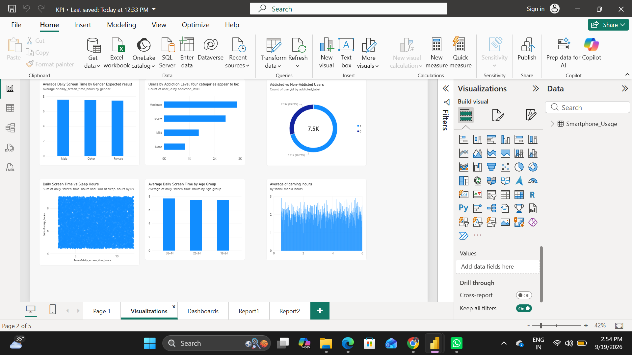

. Key Insights
- Headline KPIs include total users, addicted users, weekend screen time and sleep hours.
- Gender-based screen-time comparisons show broadly similar average levels across the displayed groups.
- The addiction-level distribution visual makes it possible to compare Moderate, Severe, Mild and None categories.
- Sleep hours are displayed by addiction level to support comparison of sleep patterns across categories.
- Weekend screen time is higher for the displayed addicted group than the non-addicted group, highlighting an important behavioral difference in this dataset.

5.Dashboards
The Dashboard sheet consolidates the most important indicators into a single interactive view. It combines KPI cards with category comparisons and filters so that a user can quickly understand the overall digital well-being profile and then investigate individual segments.
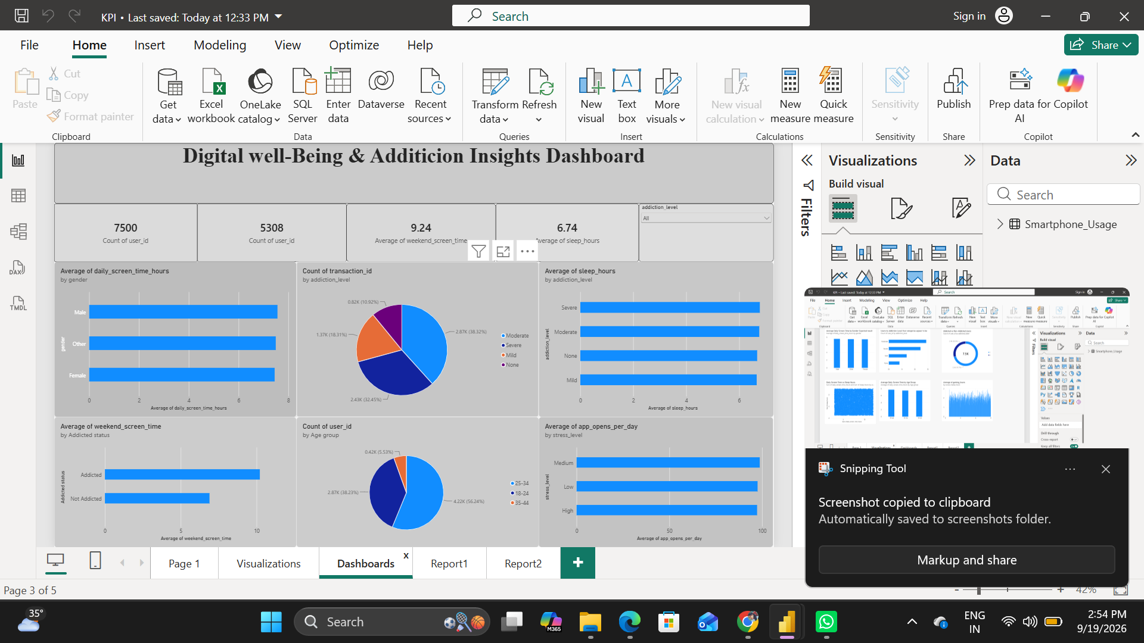

. Key Insights
- The page reports approximately 97.83 average app opens per day, indicating frequent smartphone interaction.
- Average work/study hours are approximately 3.24 hours in the displayed KPI.
- The displayed average weekend screen time is approximately 9.24 hours.
- Weekend screen time varies by addiction level, with the Severe and Moderate groups showing higher displayed averages than Mild and None.
- Age-group analysis shows a small change in average weekend screen time across the displayed age groups.
- Interactive slicers for age group, gender and stress level support focused segment analysis.

6.Report
Report1 provides a more analytical view of the dataset. It includes KPI cards, slicers, addiction-level comparisons, work/study hours, weekend screen time by addiction level, age-group trends, and a flow-style segmentation visual. The page is designed to help users move from summary indicators to demographic and behavioral segmentation.
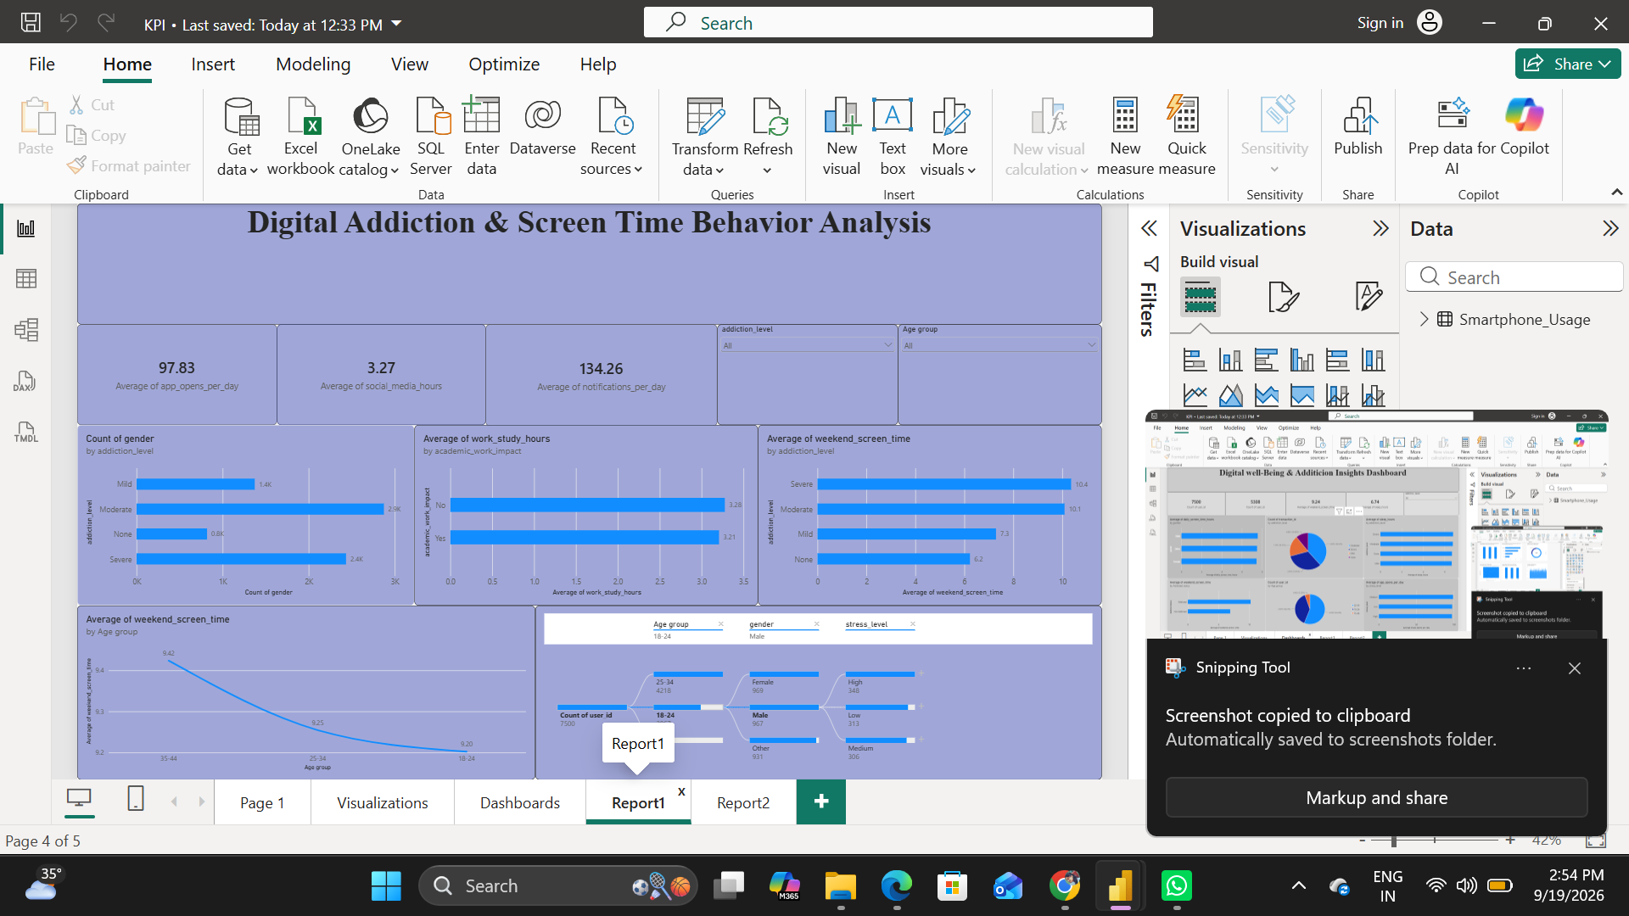

Key Insights
- Average gaming hours are approximately 2.01 hours.
- The average user age displayed in the KPI is approximately 26.57 years.
- Average work/study hours are approximately 3.24 hours.
- Stress levels are segmented into High, Low and Medium categories, supporting behavioral comparisons.
- Average social media hours differ across addiction levels, with the displayed Severe category having the highest average.
The Key Influencers visual highlights variables that are associated with the selected addiction-level category; these should be interpreted as associations rather than proof of causation

6.1 Report2
Report2 focuses on digital well-being indicators and explanatory analysis. It includes gaming hours, age, work/study hours, stress distribution, sleep by age group, high-screen-time user composition, social media usage by addiction level, and a key-influencer visual.

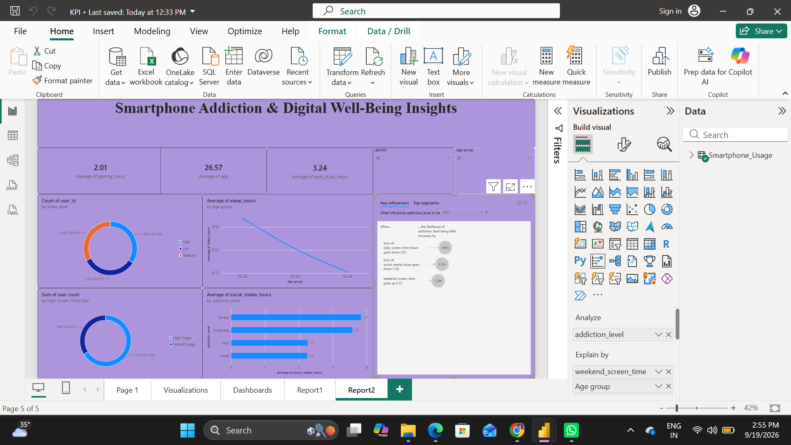.

Key Insights
- Average gaming time: Users spend about 2.01 hours/day gaming, indicating gaming is a significant part of smartphone usage.
- Average age: The dataset has an average user age of 26.57 years, suggesting the analysis largely represents young adults.
- Work/study usage: Users spend an average of 3.24 hours on work/study-related smartphone activities.
- Stress distribution: Users are fairly evenly distributed across Low, Medium, and High stress levels, with each group accounting for roughly one-third of the users.
- Screen-time pattern: High screen-time users form a larger segment than normal screen-time users in the dashboard, highlighting substantial smartphone exposure.
- Social media & addiction: Average social-media usage rises with addiction severity:
  - None: 2.2 hours
  - Mild: 2.3 hours
  - Moderate: 3.6 hours
  - Severe: 3.8 hours
- Strongest influencing factor: The Key Influencers visual indicates that daily screen-time hours has a strong relationship with addiction level, with the selected Mild category showing an approximately 4.81× increase under the displayed condition.
- Weekend usage: Weekend screen time is also identified as an influencing factor, with the visual showing approximately a 1.24× increase.
- Overall finding: The dashboard suggests that higher smartphone and social-media usage is associated with higher levels of smartphone addiction, while stress and usage patterns provide additional dimensions for understanding digital well-being

7. Performance Testing

7.1 Utilization of Data Filters
The report includes interactive slicers and filters such as addiction level, age group and gender. These controls allow the same visuals to be reused for different user segments without creating separate reports.

7.2 Number of Calculation Columns / Measures
The screenshots show multiple aggregated measures, including count of users, average age, average screen time, average social media hours, average gaming hours, average sleep hours, average notifications, average app opens and average work/study hours. The exact number of model calculations should be recorded from the Power BI Fields/Model view when submitting the final technical documentation.

7.3 Number of Visualizations
Across the four sheets, the report uses a combination of KPI cards, bar charts, donut/pie charts, relationship plots, trend visuals, slicers and a key-influencer visual. The exact visual count can be finalized from the Power BI canvas if required by the project evaluation rubric.

8. Conclusion / Observation
The Power BI analysis provides a consolidated view of smartphone usage and digital well-being behavior. The project demonstrates how raw behavioral data can be transformed into interactive KPIs, comparisons, segment analysis and explanatory visuals. The displayed results indicate substantial daily smartphone engagement, meaningful variation in weekend screen time across addiction categories, and observable differences in social media and sleep-related measures. These observations are descriptive of the dataset and should not be interpreted as causal conclusions without additional statistical analysis.

9. Future Scope
- Add time-series data to monitor changes in screen time and sleep over time.
- Create a dedicated Power BI drill-through page for individual user segments.
- Add statistical correlation and regression analysis to quantify relationships between usage variables.
- Introduce target/reference lines for healthy or project-defined usage thresholds.
- Automate refresh and publish the dashboard to Power BI Service for controlled access.
- Add mobile-friendly layouts and accessibility improvements.

10. Appendix

10.1GitHub & Project Demo Link
https://github.com/pravallika2408/Smartphone_usage-Digital-Addiction-Well-Being-Analytics

